Mosaic Learning SCORM Documentation

May 2017 – SCORM 1.2

# Software Stack

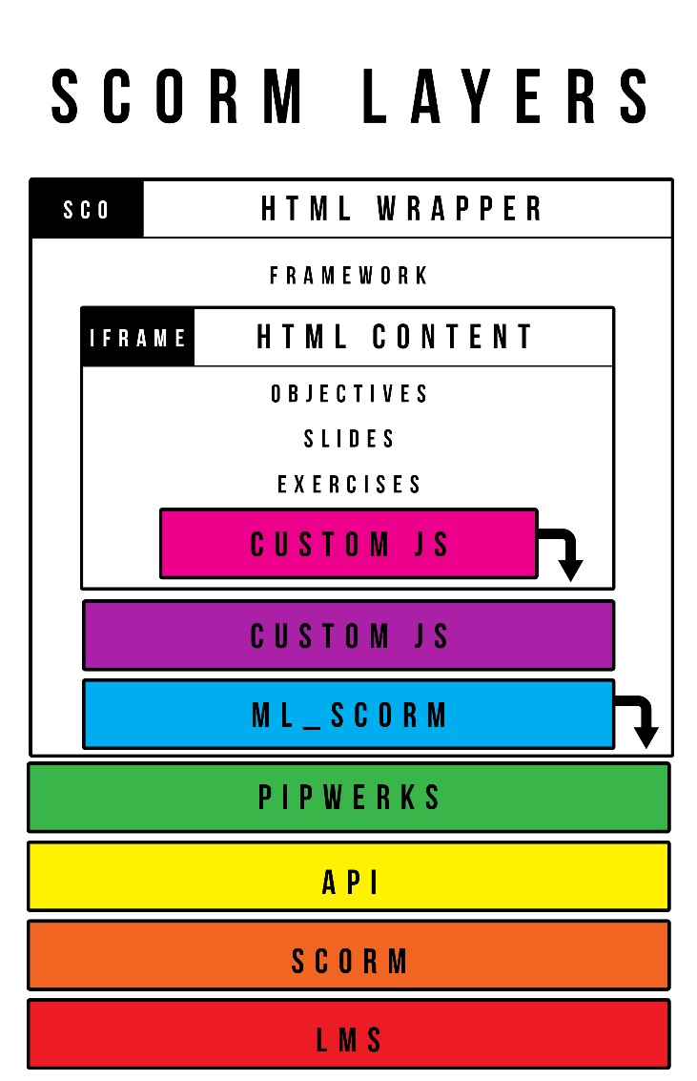When designing SCORM content this is the structure of the software that will be employed. The LMS is at the base layer, which will talk to the SCORM layer, the SCORM layer implements an API for interactions. It is possible to interact with the API directly, but for simplicities sake the use of the Pipwerks wrapper will significantly ease development.

None of the previous layers will ever need to be modified by multimedia developers. The layers that will require modification sit above the Pipwerks layer. The ML_SCORM layer is a Javascript file that is a further wrapper of the Pipwerks API with many convenience functions, simplicity shortcuts, and local constants available for consistency. This is a file that is currently in development, so while not complete, once it is more stable should need relatively little editing for day to day programming tasks.

Any custom functionality (bookmarking, objective tracking, SCO completion, exercise scoring, etc.) should be placed in a custom Javascript file that will make use of the ML_SCORM API, and occasionally the Pipwerks API. Ideally all Pipwerks functions will be wrapped in the ML_SCORM file for simplicities sake.

You should include the Pipwerks file, ML_SCORM, and your custom Javascript in each HTML file that represents your SCO, and they should be loaded in that order. If the SCO is self-contained all communication between the SCO and the LMS will be done through the custom Javascript file.

If the SCO is a wrapper for smaller lessons/objectives (as in DC Theory) the SCO HTML can also contain an iframe to load more granular content. It is important to note that the iframe will not be responsible for communicating with the LMS. It will communicate with the parent HTML which will in turn communicate with the LMS. It should not have access to the ML_SCORM or Pipwerks files. It will have its own custom Javascript file however for its internal housekeeping and to communicate with its parent layer.